**Department of Electrical Engineering and   
Computer Science**

**Faculty Member:** Dr.Ahmad Salman **Dated:** 17/02/2023

**Semester: 6**th **Section:** BEE 12C

**EE-330:** **Digital Signal Processing**

Lab 2: Complex Exponentials and Sinusoids

Group Members

|  |  |  |  |  |
| --- | --- | --- | --- | --- |
| **Name** | **Reg. No** | **Lab Report Marks** | **Viva Marks** | **Total** |
|  |  | **10 Marks** | **5 Marks** | **15 Marks** |
| Ahmed Mohsin | 333060 |  |  |  |
| Hassan Rizwan | 335753 |  |  |  |
| Syeda Fatima Zahra | 334379 |  |  |  |

**Table of Contents**

Complex Exponentials and Sinusoids 3

1.1 Objectives 3

1.2 Introduction 3

1.3 Software 3

Lab Exercises 4

2.1. M-File to generate a Sinusoid. 4

2.2. Sinusoidal Synthesis with an M-File. 5

2.3. Testing the Function in Task 2 5

2.4. Representation of Sinusoids with Complex Exponentials 6

Conclusion 8

# Complex Exponentials and Sinusoids

## Objectives

The purpose of the lab is as follows:

* Gain familiarity with complex numbers in MATLAB.
* Use complex representation of sinusoidal signals.
* Use MATLAB function commands for complex exponentials.
* Addition of Sinosoids using Complex Exponentials

## Introduction

Sinusoids can be expressed in terms of complex exponentials. MATLAB contains some in-built complex functions as well to plot and visualize these sinusoids. The sinusoids can be expressed in the following form:

$x\left(t\right)=Acos\left(2πf_{o}t+∅\right)=Real\{Ae^{jθ}e^{2jπf_{0}t}\}$

The *Phasor Addition Rule* shows how to add several sinusoids:

$$x\left(t\right)=\sum_{k=1}^{N}{A_{k}cos\left(2πf_{o}t+∅\right)}$$

## Software

MATLAB R2022b



# Lab Exercises

## M-File to generate a Sinusoid.

1. Write a function that will generate a single sinusoid, $x\left(t\right)=Acos\left(ωt+∅\right)$ by using four input arguments: amplitude (A), frequency (ω), phase (*ɸ*) and duration (dur). The function should return two outputs: the values of the sinusoidal signal (x) and corresponding times (t) at which the sinusoid values are known. Make sure that the function generates 20 values of the sinusoid per period. Call this function one_cos(). *Hint: use* goodcos() *from previous Lab as a starting point.* Demonstrate that your one_cos() function works by plotting the output for the following parameters: A = 95, ω = 200 rad/sec, *ɸ* = π/5 radians, and dur=0.025 seconds. Be prepared to explain to the lab instructor features on the plot that indicates how the plot has the correct period and phase. What is the expected period in millisecond?

**Code:**

function [x,t]=one_cos(A,w,phi,dur)

t=0:1/(20*w):dur;

x=A*cos((w*t)+phi);

plot(t,x)

title('Cosine Function')

end

**Output:**

The expected period is given as T=1/w=0.0025.

## Sinusoidal Synthesis with an M-File.

Write an M-file called syn sin.m that will synthesize a waveform in the form of (7).

$x\left(t\right)=Real\{\sum_{k=1}^{N}{X_{k}}e^{j2πf_{k}t}\}$ (7)

**Code:**

|  |
| --- |
| function [xx,tt] = syn_sin(fk, Xk, fs, dur, tstart)  tt=tstart:1/fs:dur;  xx=0;  if length(fk) == length(Xk)  for k=1:length(fk)  xx = xx + real(Xk(k)*exp(2j*pi*fk(k)*tt));  end  plot(tt,xx);  else  error('Lengths of fk and Xk are different')  end |

## Testing the Function in Task 2

In order to use this M-file to synthesize harmonic waveforms, you must choose the entries in the frequency vector to be integer multiples of some desired fundamental frequency. Try the following test and plot the result.

*[xx0,tt0] = syn_sin([0,100,250],[10,14*exp(-j*pi/3),8*j],10000,0.1,0);*

**Output:**

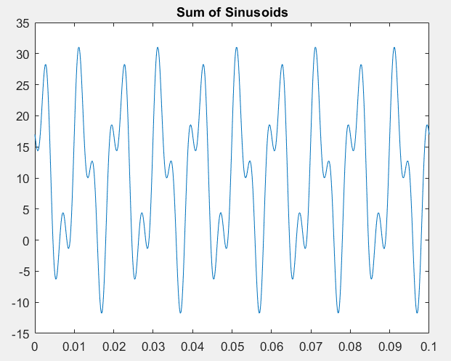

Measure the period of xx0 by hand. Then compare the period of xx0 to the periods of the three sinusoids that make up xx0?

The period of the first signal with frequency 100 is 0.01s. The period of the second signal with frequency 250 is 0.004. The period of xx0, the resulting signal, is the LCM of these two periods, which is 0.002s, which can be verified from the plot as well. The period of xx0 is this greater than the periods of the signals that make it.

## Representation of Sinusoids with Complex Exponentials

1. Generate the signal and make a plot versus t. Use the syn_sin function and take a range for t that will cover three periods starting at t = −0.5 secs. *Include the* MATLAB *code with your report.*



**Code:**

function [xx,tt] = Task4 (fk, Xk, fs, dur, tstart)

tt=tstart:1/fs:dur-abs(tstart);

xx=0;

if length(fk) == length(Xk)

for k=1:length(fk)

xx = xx + real(Xk(k)*exp(2j*pi*fk(k)*tt));

end

plot(tt,xx);

title('Sinusoid using Complex Exponentials')

else

error('Lengths of fk and Xk are different')

end

**Output:**

* 1. From the plot of x(t) versus t, measure the frequency, phase and amplitude of the sinusoidal signal by hand. Show annotations on the plots to indicate how these measurements were made and what the values are.

T = x2-x1

= 3.9-2.9 = 2s

f = 1/T = 0.5 Hz

A = 1.636

Φ = 360° ( $\frac{del T}{T}$) = 15.26°, where T = 0.08475 (from the plot)

* 1. Use the phasor addition theorem and MATLAB to determine the magnitude and phase of x(t).

**Code:**

function[xx,tt] = syn_sin()

fk = [1, 1, 1];

Xk = [2*exp(1i*pi), 2*exp(1i*pi*(1-1.25)),(1-1i)*exp(1i*pi)];

fs = 100; % Samples per second

dur = 3/min(abs(fk)); % Total time duration to cover three periods

tstart = -0.5; % Starting time

if nargin < 5

tstart = 0;

end

if length(fk) ~= length(Xk)

error('Error: frequency and amplitude vectors must have the same length');

end

dt = 1/fs;

tt = tstart:dt:tstart+dur-dt;

N = length(fk);

xx = zeros(size(tt));

for k = 1:N

xx = xx + real(Xk(k) * exp(1i * 2 * pi * fk(k) * tt));

end

x_phasor = sum(Xk); % phasor addition of all components

x_magnitude = abs(x_phasor); % magnitude of x(t)

x_phase = angle(x_phasor); % phase of x(t)

fprintf('The magnitude of x(t) is %f\n', x_magnitude);

fprintf('The phase of x(t) is %f rad\n', x_phase);

% Plot the signal

figure;

plot(tt,real(xx));

xlabel('Time (seconds)');

ylabel('Amplitude');

title('Signal x(t)');

grid on;

end

**Output:**





# Conclusion

In this lab we studied how to use complex exponential functions to make sinusoids in MATLAB. We learnt the use of for loops, complex exponentials, and how to synthesize sinusoids using complex exponentials. We also learnt about fundamental period and harmonics and how to calculate them.